ACEC-IA Company Membership (Multi-User License) Key Contacts

Membership Types: Your company has a membership type with a multi-user license, with at least one Key Contact that has been identified for your organization on the ACEC-IA website.

Key Contacts: If you have been identified as a Key Contact, then you will have additional access and permissions on the website than other employees who are not Key Contacts.

Main Profile Page: Once you log in using your Username and Password, you will be directed to your Main Profile Page where you will see a name badge with your contact information on it.

Member Example:
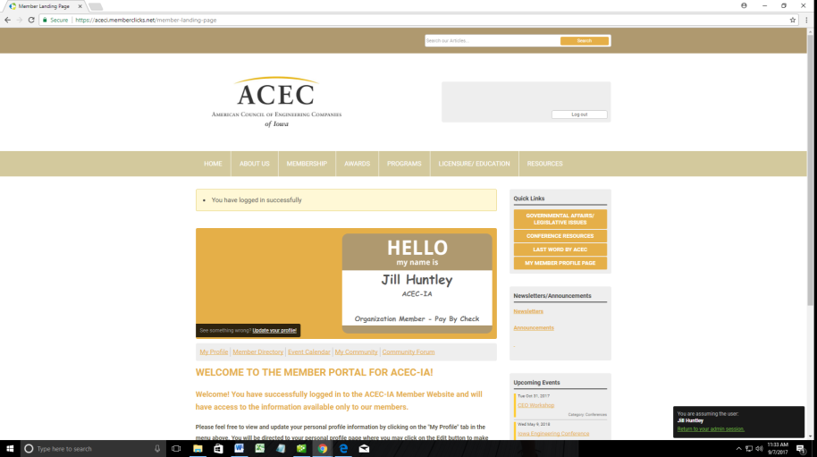

Personal Profile: If you click on the My Profile link on the Main Profile Page, you will be directed to your personal profile. As a member, you have access to many features that non-members are not able to see, including the data under your profile. If you scroll down on this page, you will see the information we have for you and an EDIT button which allows you to make changes/updates to your contact information if necessary. It is VERY important to keep this information updated as this is the contact information we use to communicate with you.
In addition, if you hover your cursor over the Member Menu items: My Community, My Profile, Connections, My Features and Inbox, you will see many more options and features you have access to as an ACEC-IA member. Please take time to become familiar with these features.

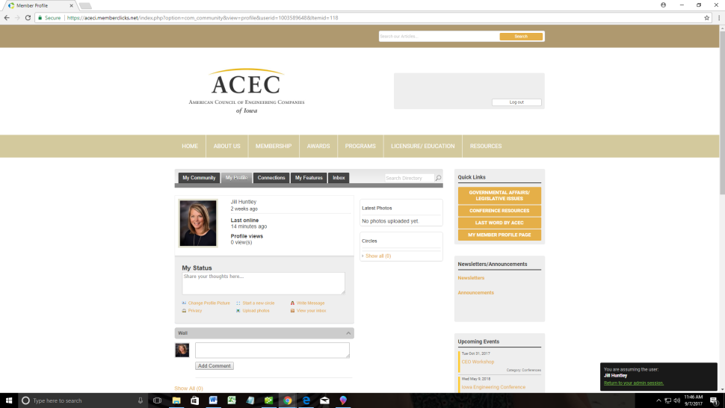

Your Organization (Not a Key Contact): Any Company Contacts who are NOT designated as the Key Contact will have a “Your Organization” button under the My Profile tab. If selected, they will be directed to the organizational page for your company (verses your own personal profile page- see below). However, this is just an informational page without any menu options at the top and no ability to edit.
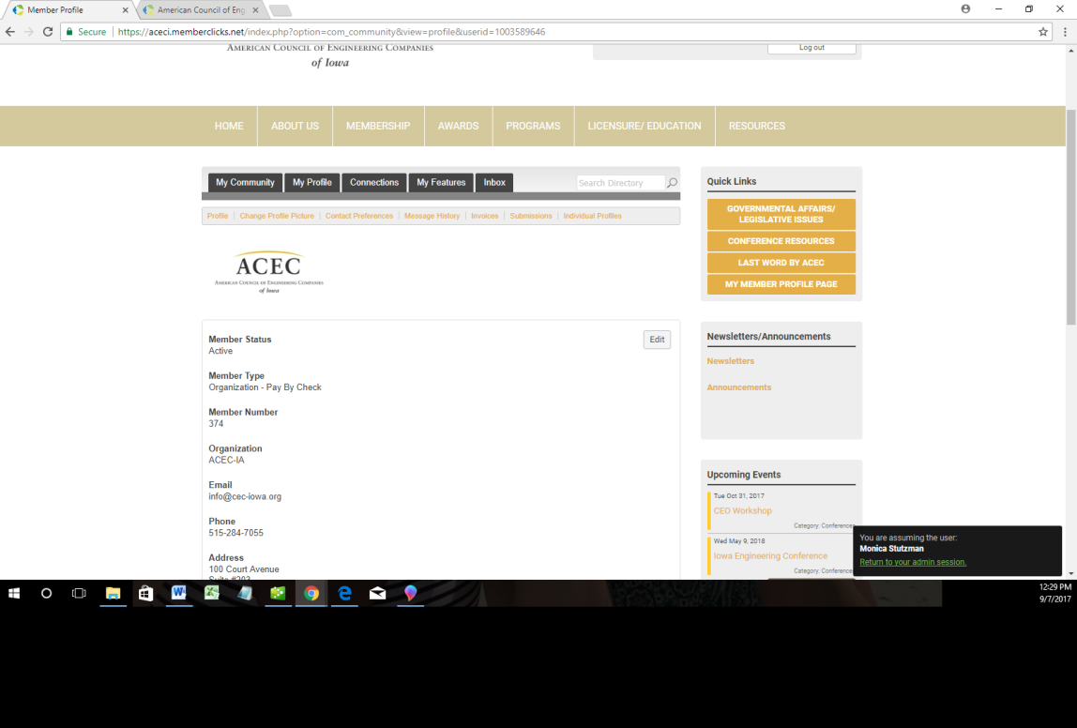

Your Organization (As a Key Contact): As the Key Contact, if you select the “Your Organization” button under the My Profile tab, you will be directed to the organizational page for your company (verses your own personal profile page- see below). As the Key Contact, you will have access to a menu with several features, as well as to the EDIT button in order to update the data in the fields for your company (See below).

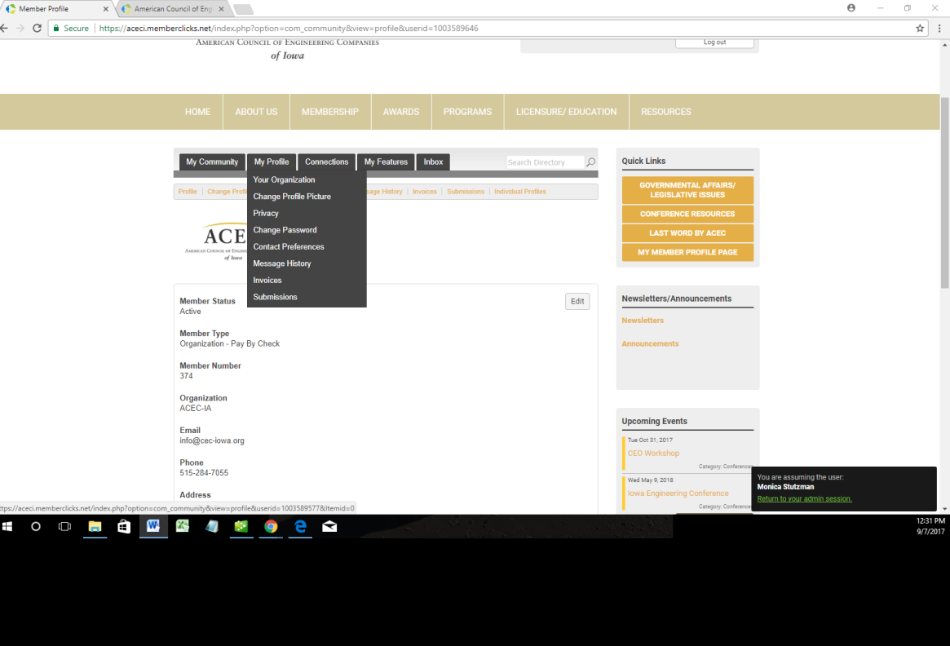
Key Contact Menu: The menu bar with small gold font labels, directly under the tabs in brown, is only accessible to Company Key Contacts. Only the main profile page is available for all company members to view.

Change Profile Picture: Key Contacts may update/change the company logo, if necessary.

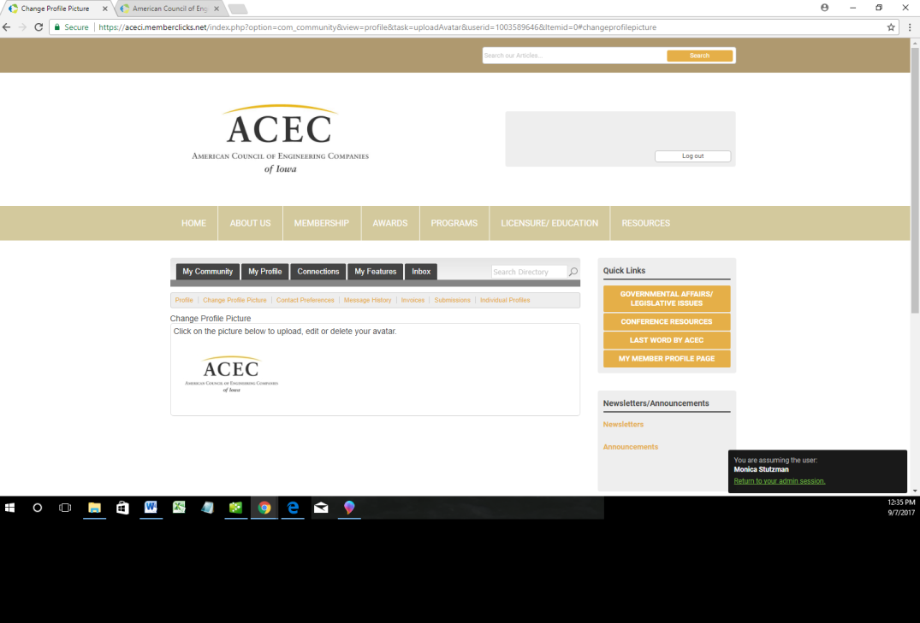

Contact Preferences: Key Contacts may determine the types of notifications your company wishes to receive.

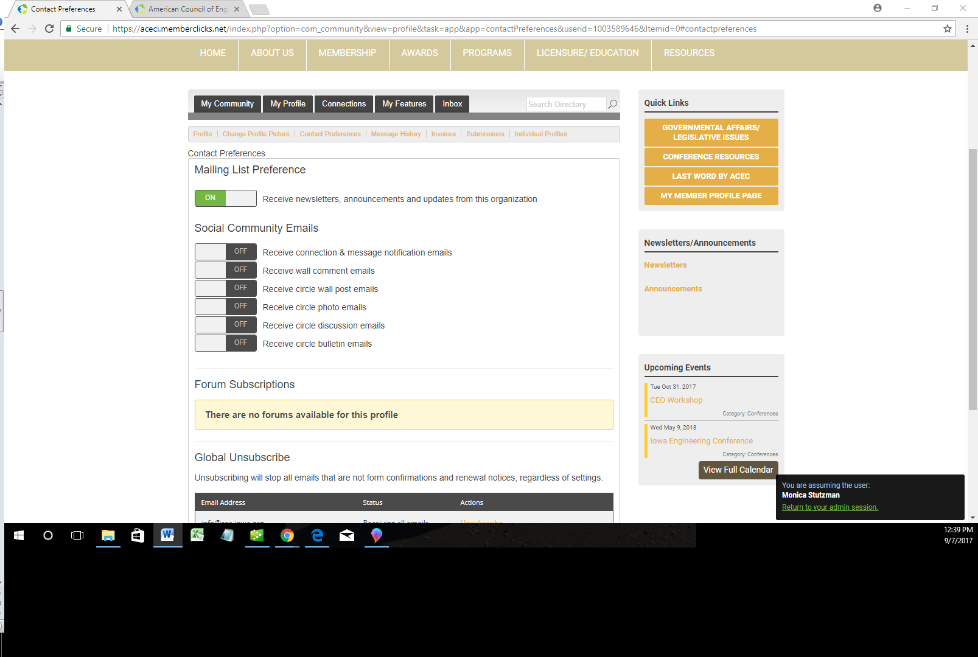

Message History: Key Contacts may see any messages that have been generated and sent to them, as well as the status and date sent.

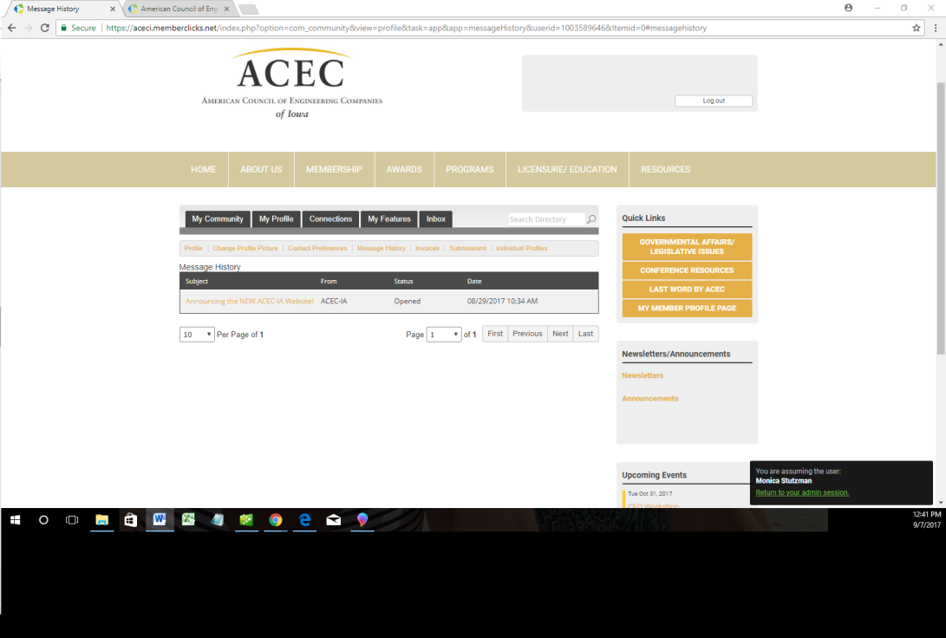

Invoices: Key Contacts may view any Invoices that have been generated by the organization and their status, as well as a link to open the invoice. This will open an interactive document with buttons at the bottom with options to Pay Invoice online for outstanding balances with a credit card or Download Invoice if you wish to print or save a copy. A historical record of past and present invoices will be kept here.

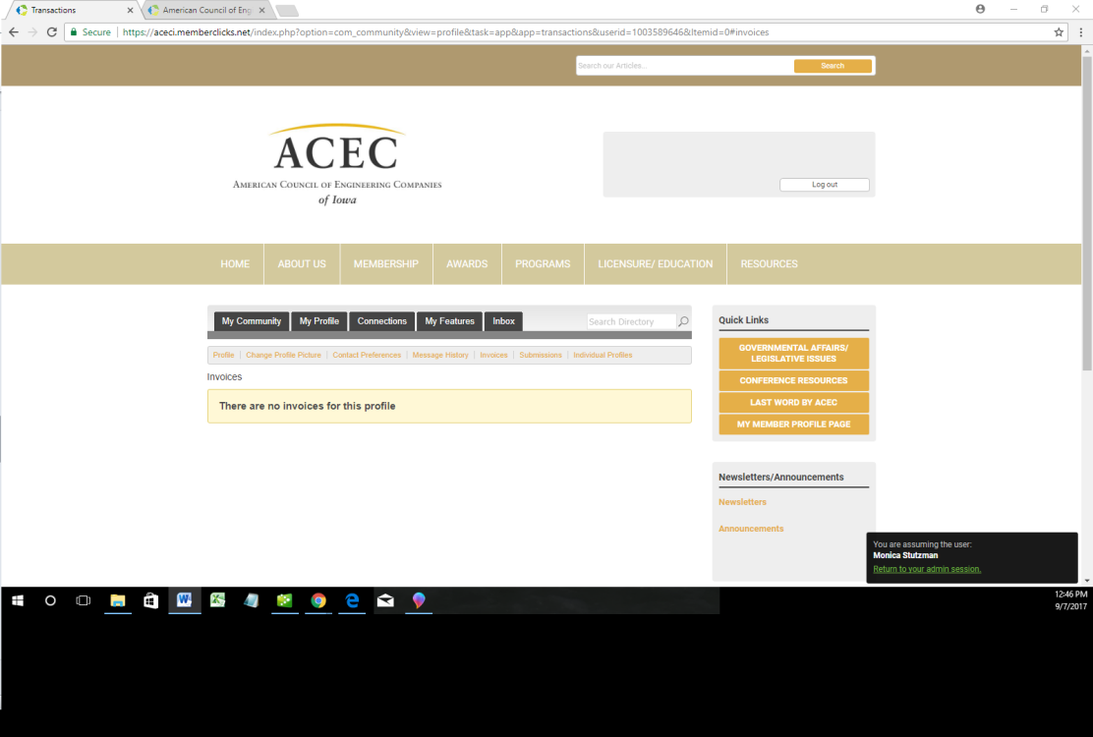

Submissions: Key Contacts may view any forms that have been generated or completed under the organizational profile, as well as a link to any invoices.

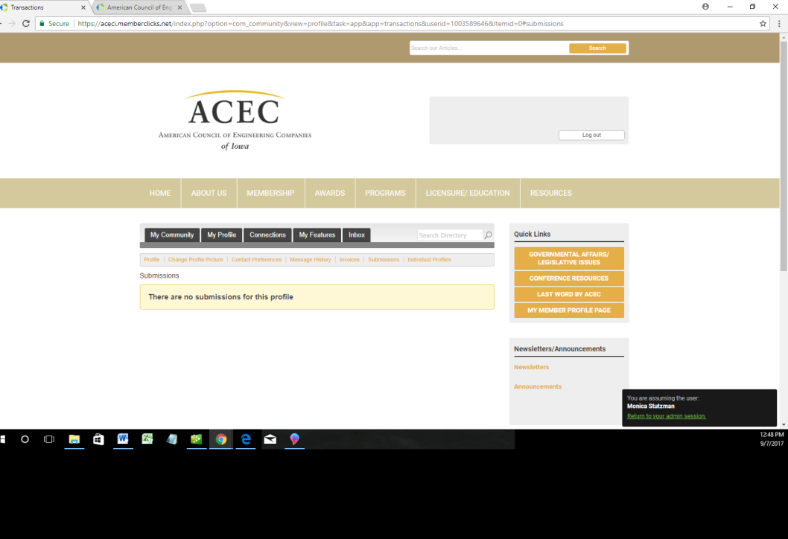

Individual Profiles: Key Contacts (KC) have access to the list of all of the company employees who have been linked to this company membership. The KC may designate any other Key Contacts who will have the same permissions and access on the ACEC-IA site or Unlink any members who are no longer a part of the organization’s membership.

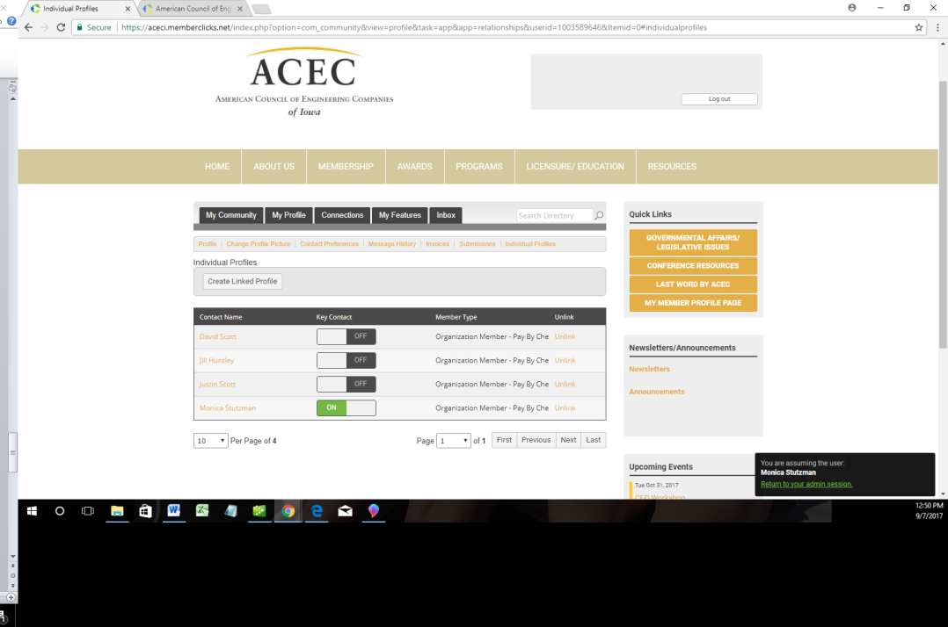

The KC’s are also able to click on the individual member’s name in this list which will direct you to that member’s personal profile.

Individual’s Personal Profile: As a Key Contact, you have permission to edit or change any of the fields that populate when you click on the EDIT button for this member, in order to keep our database current.

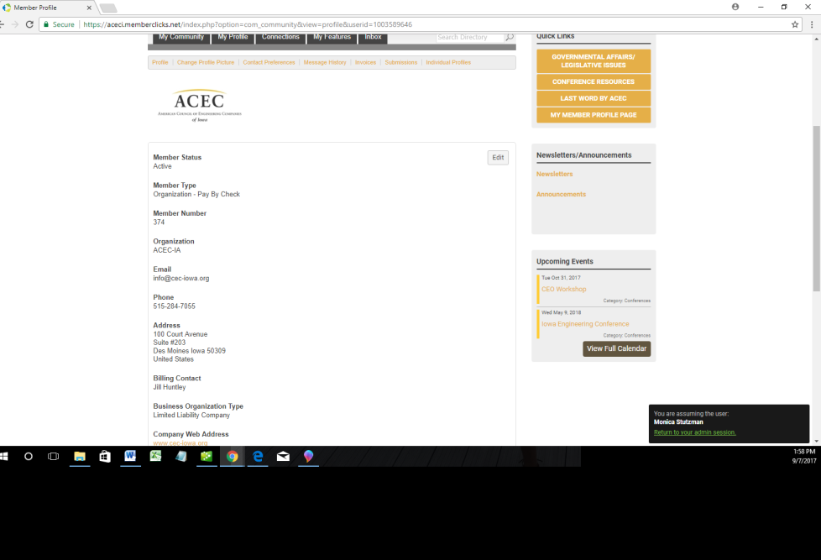

Event Registration: If you are interested in registering other linked members, click on the Register button under the event and it will should give you that option.

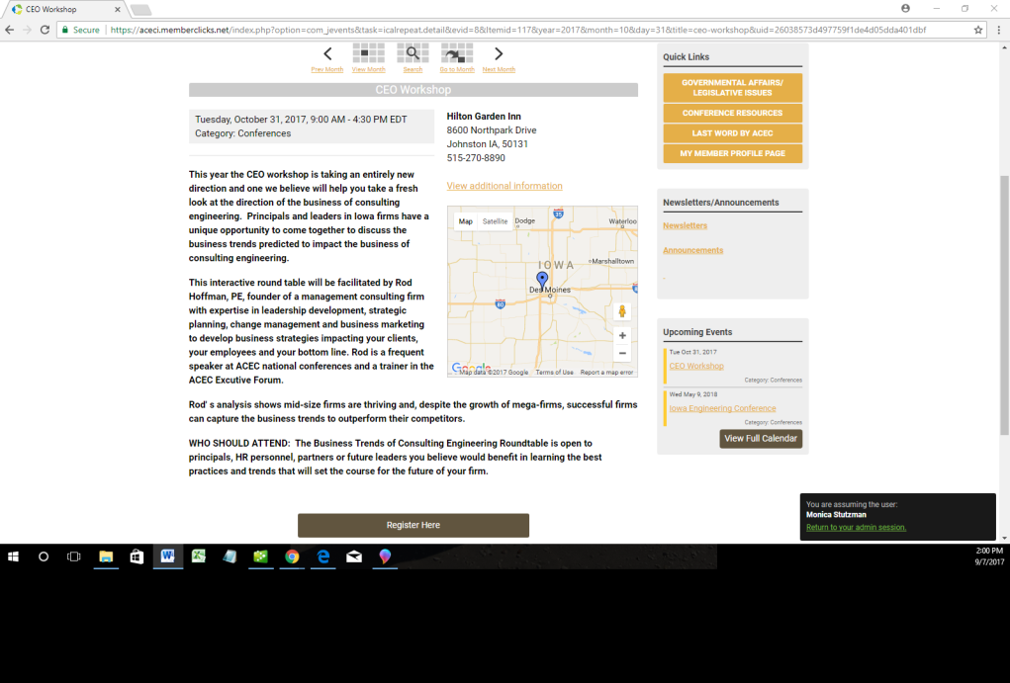

Register Linked Profile: This option should be available for Key Contacts in order to register other linked members for an event.

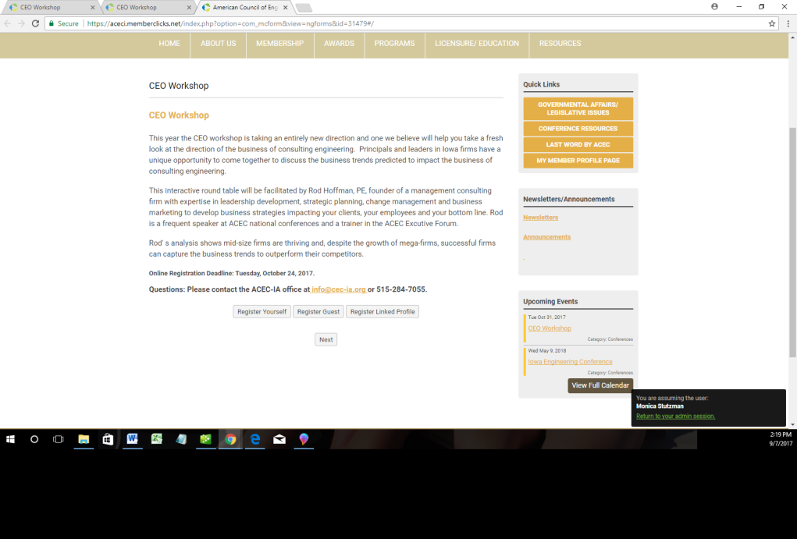

We hope this helps to identify the additional access and features of the Company Membership’s Key Contacts for the ACEC-IA website. You may choose how many and who from your organization has the permission for this level of access.

Please contact the ACEC-IA Section office at info@cec-ia.org or 515-284-7055 with any questions or if we may be of assistance. We hope you will enjoy the many benefits and features this site has to offer for our ACEC-IA members.

Thank you!
ACEC-IA

