Setting Up Created Linked Profiles for Log In

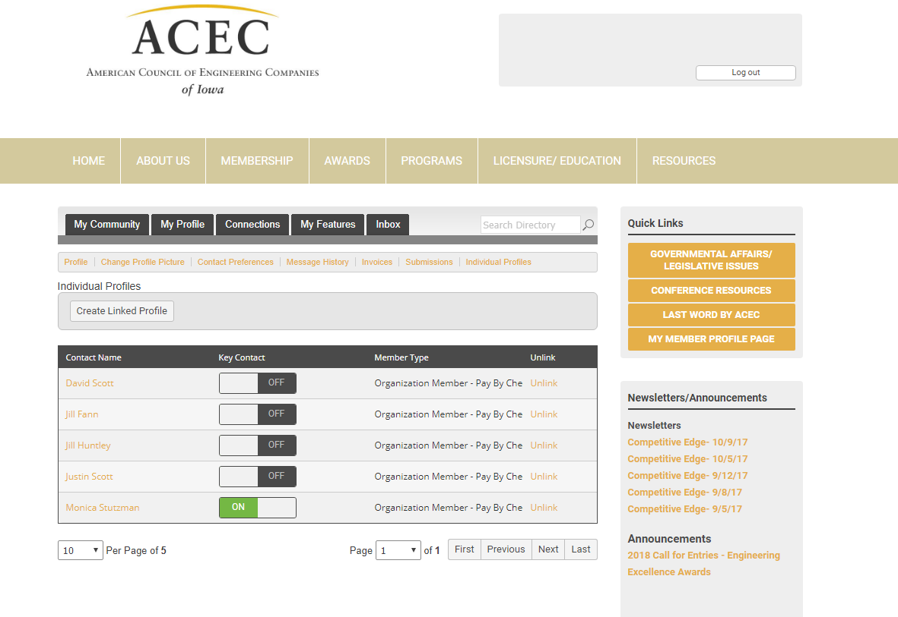
1. Create the Linked Profiles by using the –Create Linked Profiles Button. This can only be done by the key contacts of the company.

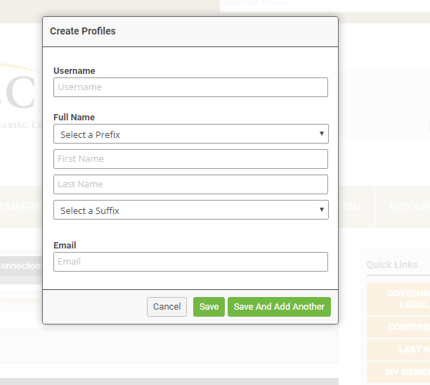
2. Fill in the Profile information.
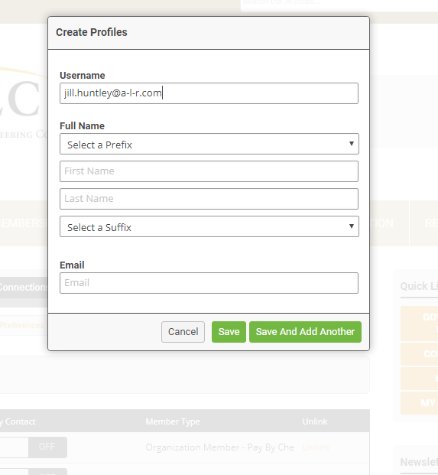

3. We suggest using the profile’s email address as the username. Please make sure to share the username with the individual.

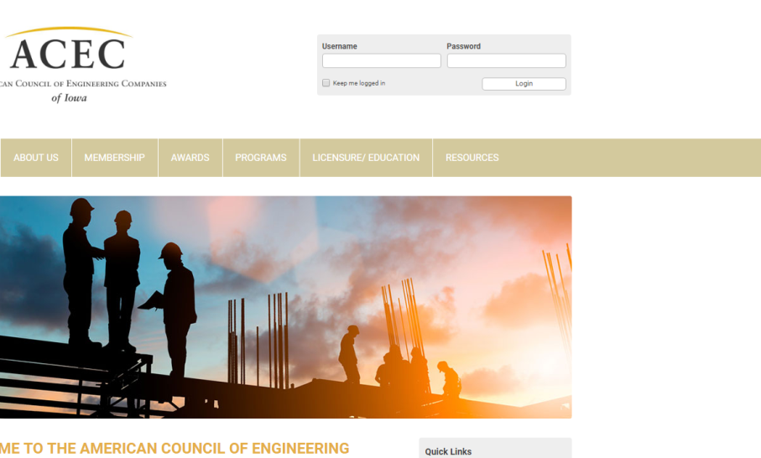
4. A password will need to set for the new profile. The new linked profile will need to go the ACEC-IA home page- www.cec-iowa.org. Next they should click on the login button at the top of the page. Username may used but is not necessary.

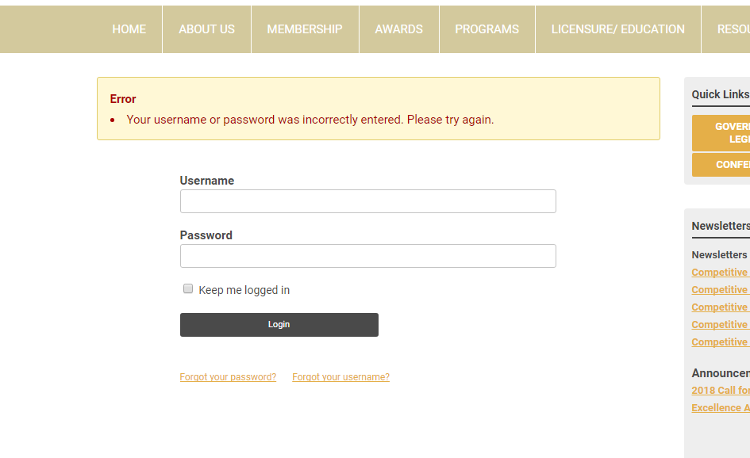

5. Click on the – Forgot your password link.
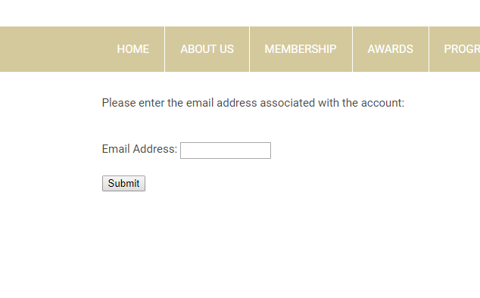
6. A box will pop up asking you to enter your email address. Please make sure it is the same email address that is used in the profile.

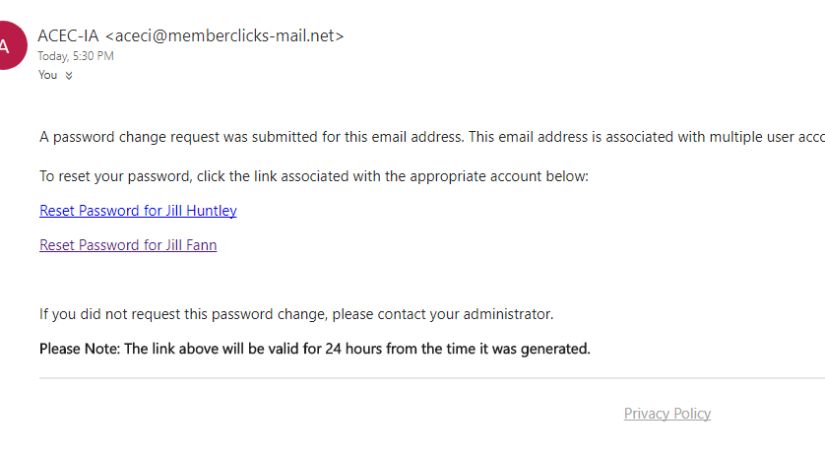
7. An email will be sent to the profile’s inbox. If you do not receive it, please check your junk mail. Click on the link. You will be directed to a page that asks you to set a new password. See below.

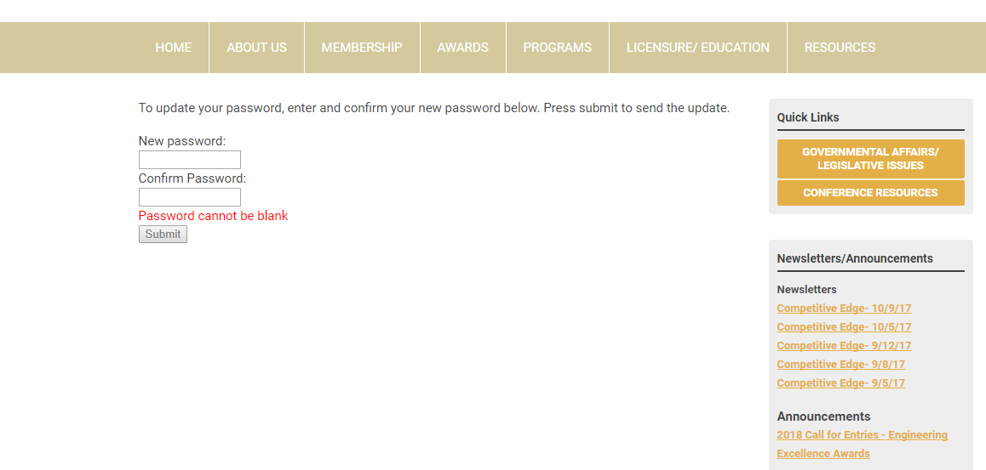

8. You will be able to log into the website with your username and password now.

